AICE Website – Rebuild Elementor
Ella Notes 17/03/26

Course Overview
- Can we make this like the current display? It is a hyperlink that takes them straight to the website, instead of the URL displayed.

 - new

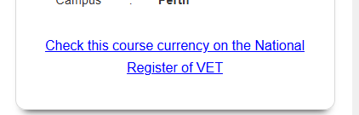 - original

- The below ‘Get in Touch’ needs to be hyperlinked



- Could we put a space between each paragraph? Just so it reads a bit clearer?

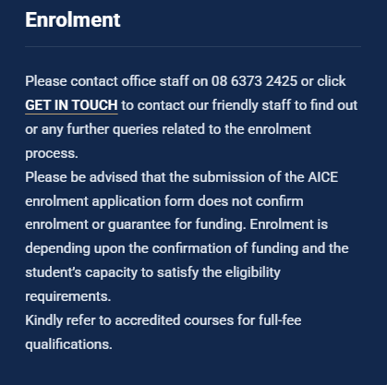

CHC33021 Certificate III in Individual Support (Ageing and Disability)

- The government funded only needs the below logos – please remove the free?


CHC52021 Diploma of Community Services

- Please make the below under Course Fees a hyperlink to open in new tab:



CHC33021 Certificate III in Individual Support (Ageing and Disability)

- Qualification Requirements hyperlinked URL

CHC52021 Diploma of Community Services

- Please fix bolding below under Pathways to Further Study

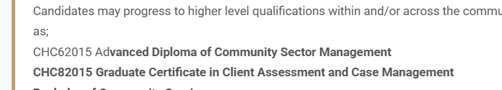

SIT40422 Certificate IV in Hospitality

- The duration is incorrect.
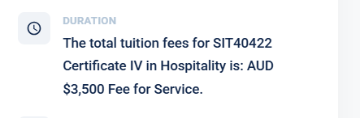

SIT50422 Diploma of Hospitality Management

- Please change heading to Qualification Requirements

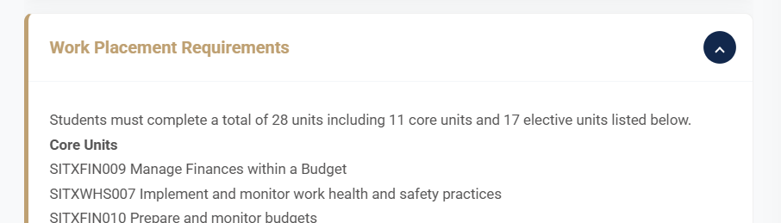

HLTAID011 Provide First Aid

- Please change heading to Qualification Requirements

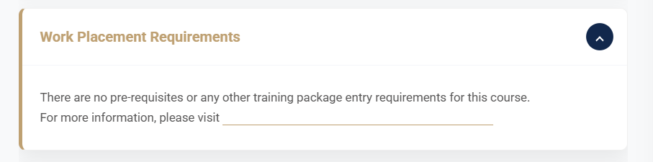

INTERNATONAL COURSES

CHC33021 Certificate III in Individual Support (Ageing and Disability) (116973E)

- Missing information in the entry requirements

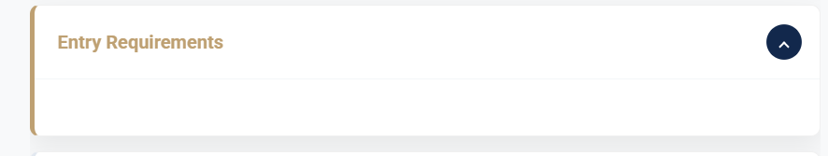

SIT40422 – Certificate IV in Hospitality (116974D)

- Please hyperlink

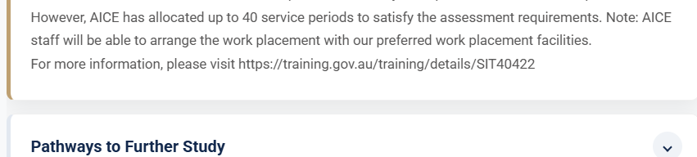

Form Pop-up
- The new form looks fantastic. Can we please add this new form pop-up to footer and anywhere else on the website too so it's a universal pop-up form? Even on areas like the Start Date section that says to email info@aice.edu.au - I would like that to be the pop-up form too so we can track every enquiry.

- International Student is missing the 's' on the end. Should be International Students



Agents Page

- The writing on the Agent page has almost a faded white highlight behind it - could we fix this to be clearer?



- Could we please add the attached Agent Application Form to this page? Below is how AMA Training display theirs – could we do something similar?

